

Institute Of Computer Technology
B. Tech Computer Science & Technology
Sub: Artificial Intelligence (AI)
Practical - 02

Name: Panchal Darshan
Enrolment No.: 22162121007
Subject: AI
Branch: BDA
Batch: 63
Semester: 6
Date of Creation: 25/01/2026
Date of Submission: 28/01/2026

GitHub Link –
- AIM - Develop the following two intelligent agents using the language of your choice. Define PEAS for both of them.

- I have used Experta Library to solve these two problems!!

- Create a facial gesture selection Agent.
Code Input:
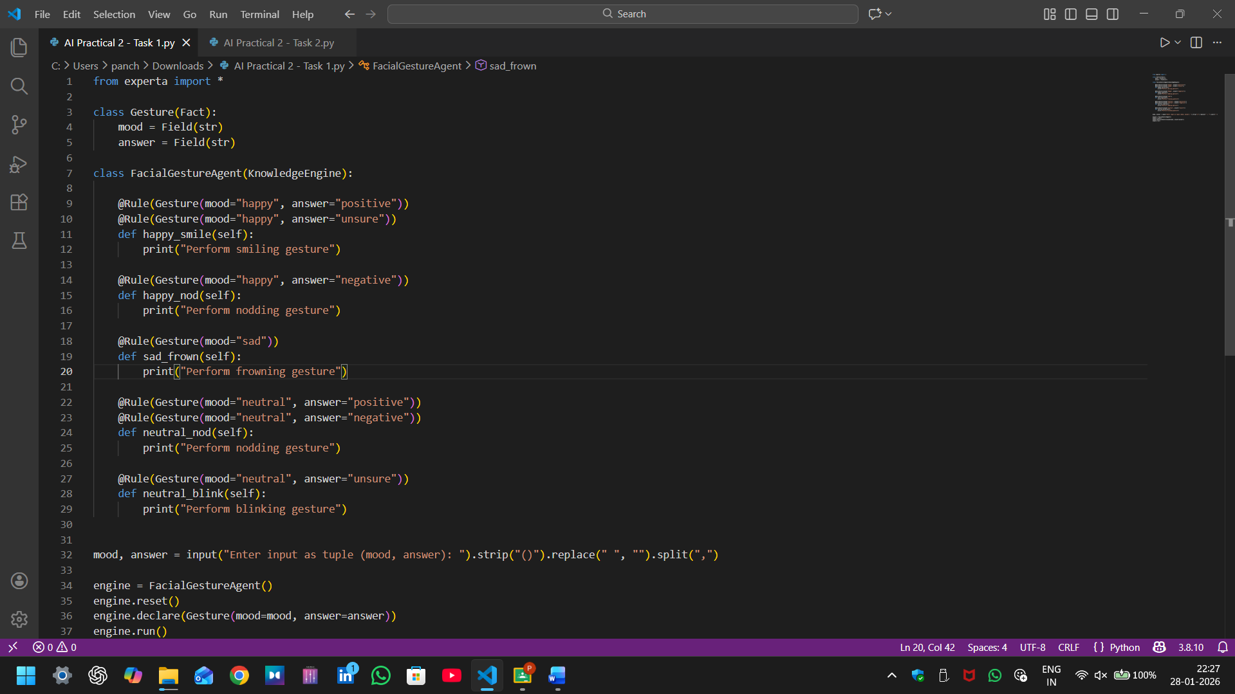

from experta import *

class Gesture(Fact):
mood = Field(str)
answer = Field(str)

class FacialGestureAgent(KnowledgeEngine):

@Rule(Gesture(mood="happy", answer="positive"))
@Rule(Gesture(mood="happy", answer="unsure"))
def happy_smile(self):
print("Perform smiling gesture")

@Rule(Gesture(mood="happy", answer="negative"))
def happy_nod(self):
print("Perform nodding gesture")

@Rule(Gesture(mood="sad"))
def sad_frown(self):
print("Perform frowning gesture")

@Rule(Gesture(mood="neutral", answer="positive"))
@Rule(Gesture(mood="neutral", answer="negative"))
def neutral_nod(self):
print("Perform nodding gesture")

@Rule(Gesture(mood="neutral", answer="unsure"))
def neutral_blink(self):
print("Perform blinking gesture")

mood, answer = input("Enter input as tuple (mood, answer): ").strip("()").replace(" ", "").split(",")

engine = FacialGestureAgent()
engine.reset()
engine.declare(Gesture(mood=mood, answer=answer))
engine.run()

Code Output:
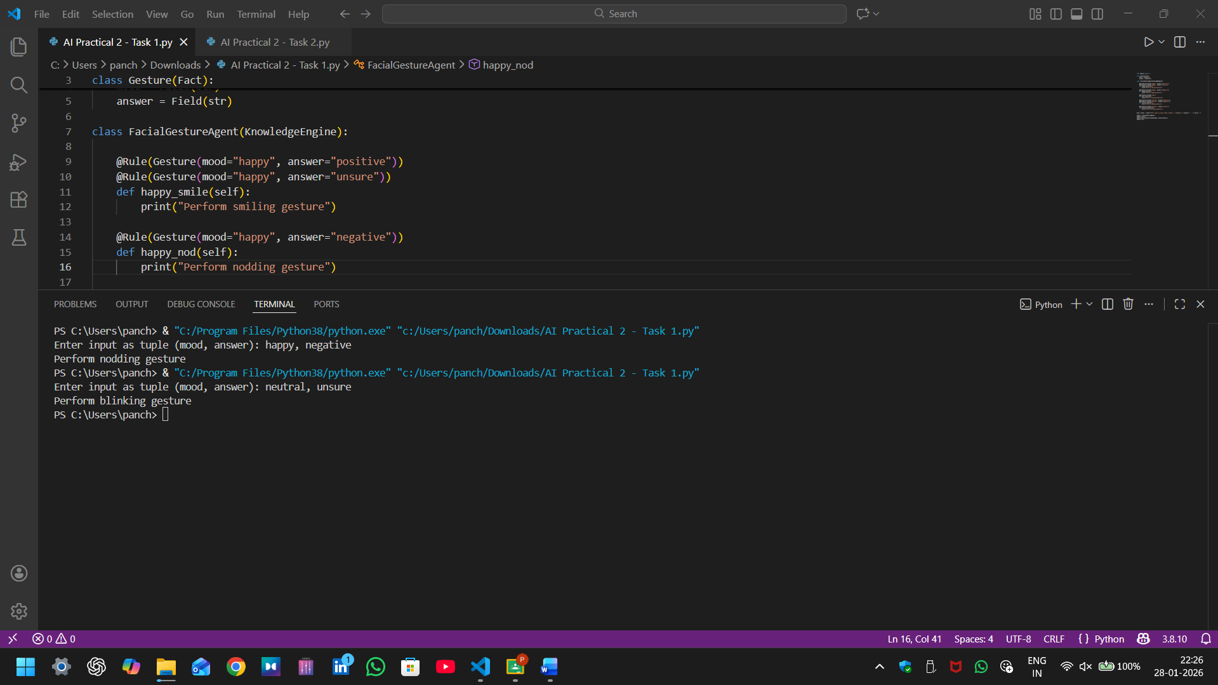

- PEAS Definition – Facial Gesture Selection Agent

1. P = Performance Measure:
- Correct selection of facial gesture based on mood and answer
- Natural and context-appropriate gesture output.
- Zero ambiguity in rule execution

2. E = Environment:
- Interactive, user-driven environment
- Non-real-time, software-based system
- Input provided as a tuple: (mood, answer)

3. A = Actuators:
- Perform Smile
- Perform Nod
- Perform Blink
- Perform Frown

4. S = Sensors:
- Mood input: happy, sad, neutral
- Answer input: positive, negative, unsure

- Create a Respiratory illness classification agent.
Code Input:
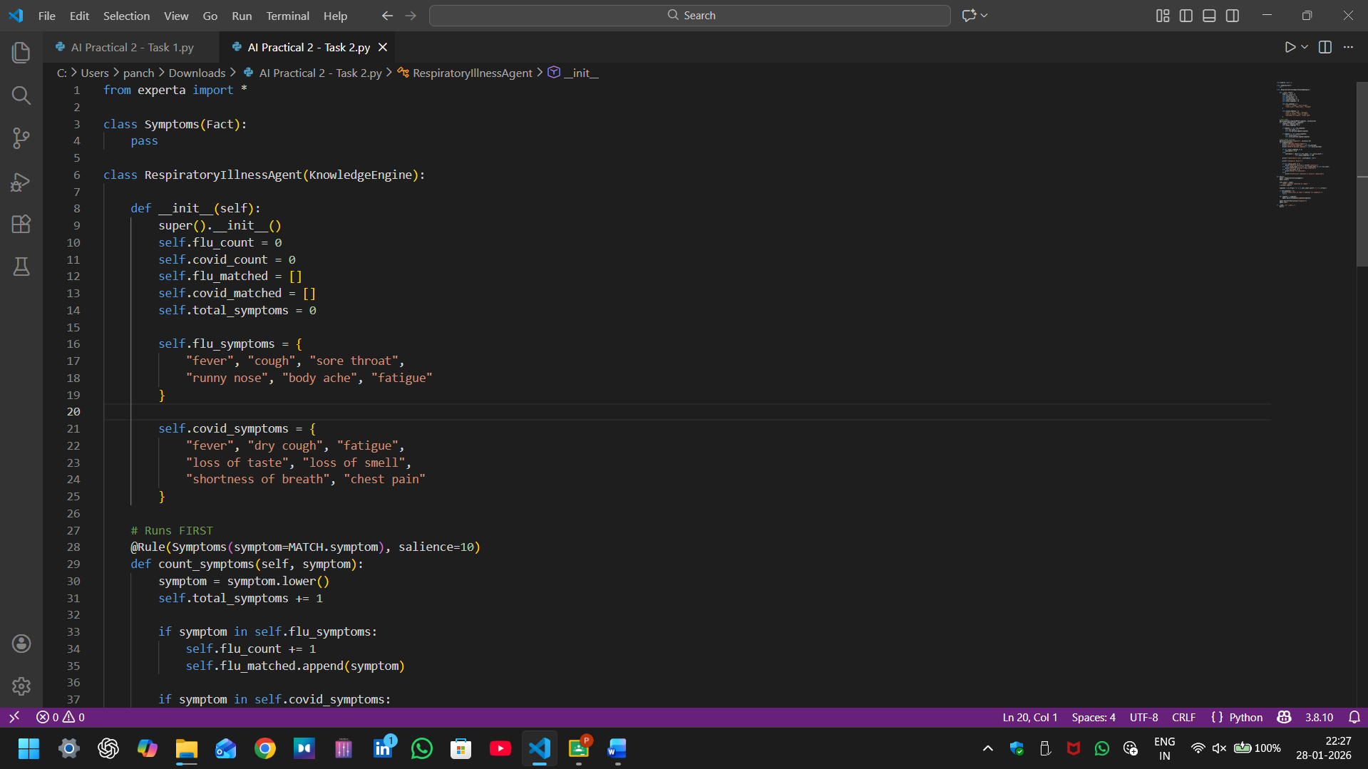
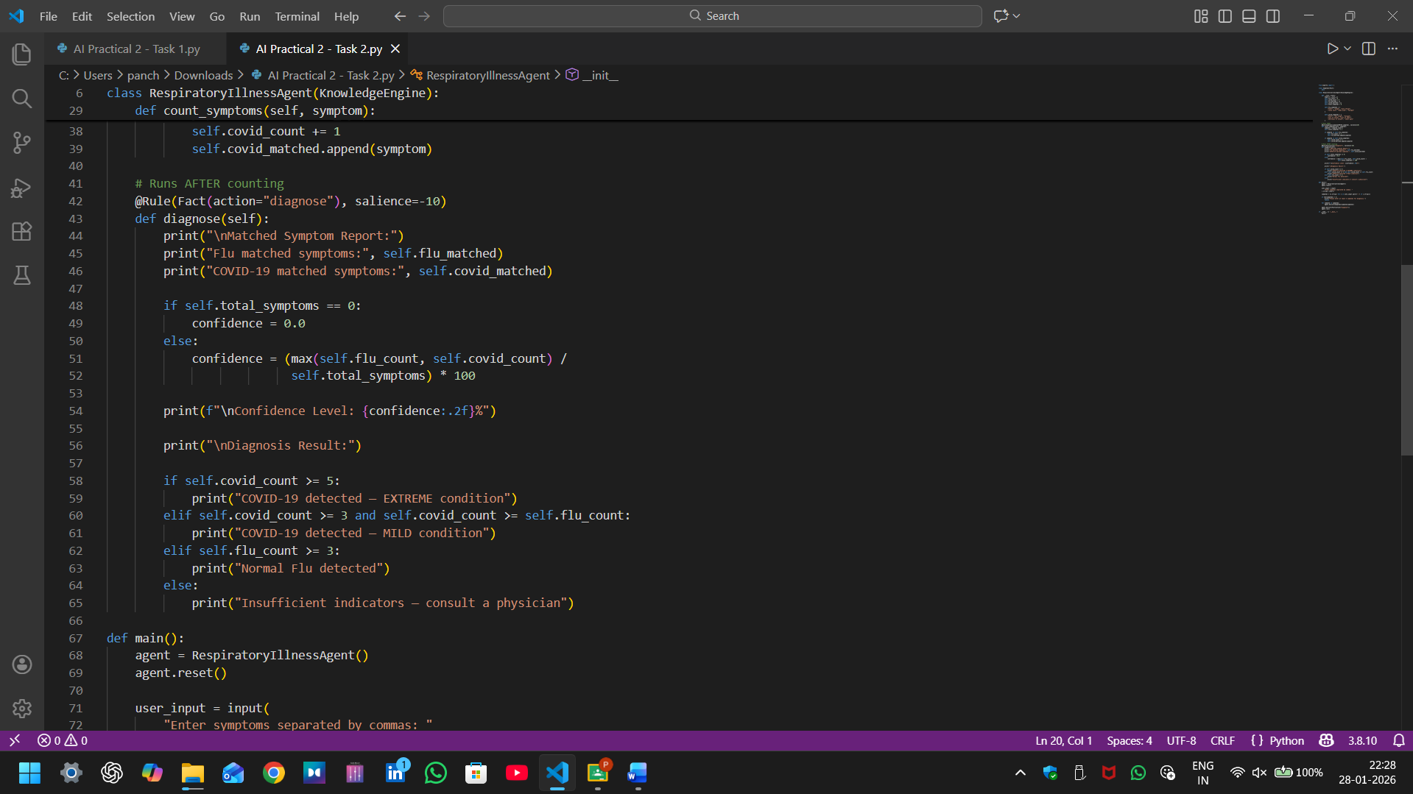
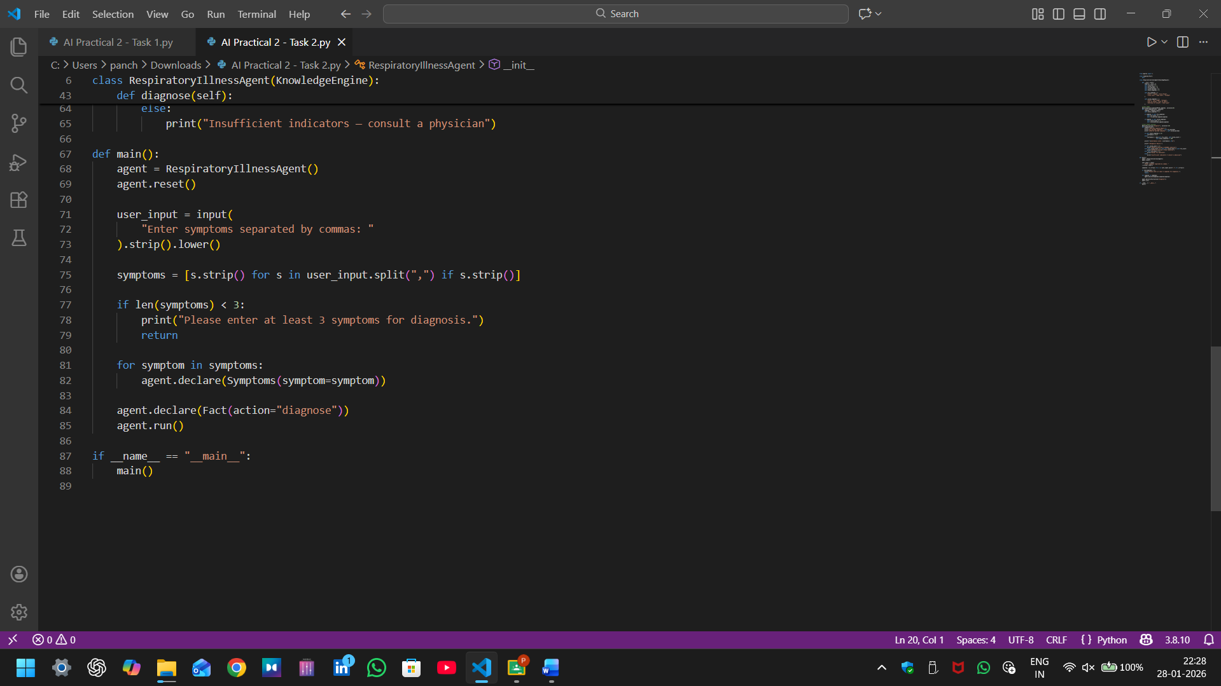

from experta import *

class Symptoms(Fact):
pass

class RespiratoryIllnessAgent(KnowledgeEngine):

def __init__(self):
super().__init__()
self.flu_count = 0
self.covid_count = 0
self.flu_matched = []
self.covid_matched = []
self.total_symptoms = 0

self.flu_symptoms = {
"fever", "cough", "sore throat",
"runny nose", "body ache", "fatigue"
}

self.covid_symptoms = {
"fever", "dry cough", "fatigue",
"loss of taste", "loss of smell",
"shortness of breath", "chest pain"
}

# Runs FIRST
@Rule(Symptoms(symptom=MATCH.symptom), salience=10)
def count_symptoms(self, symptom):
symptom = symptom.lower()
self.total_symptoms += 1

if symptom in self.flu_symptoms:
self.flu_count += 1
self.flu_matched.append(symptom)

if symptom in self.covid_symptoms:
self.covid_count += 1
self.covid_matched.append(symptom)

# Runs AFTER counting
@Rule(Fact(action="diagnose"), salience=-10)
def diagnose(self):
print("\nMatched Symptom Report:")
print("Flu matched symptoms:", self.flu_matched)
print("COVID-19 matched symptoms:", self.covid_matched)

if self.total_symptoms == 0:
confidence = 0.0
else:
confidence = (max(self.flu_count, self.covid_count) /
self.total_symptoms) * 100

print(f"\nConfidence Level: {confidence:.2f}%")

print("\nDiagnosis Result:")

if self.covid_count >= 5:
print("COVID-19 detected — EXTREME condition")
elif self.covid_count >= 3 and self.covid_count >= self.flu_count:
print("COVID-19 detected — MILD condition")
elif self.flu_count >= 3:
print("Normal Flu detected")
else:
print("Insufficient indicators — consult a physician")

def main():
agent = RespiratoryIllnessAgent()
agent.reset()

user_input = input(
"Enter symptoms separated by commas: "
).strip().lower()

symptoms = [s.strip() for s in user_input.split(",") if s.strip()]

if len(symptoms) < 3:
print("Please enter at least 3 symptoms for diagnosis.")
return

for symptom in symptoms:
agent.declare(Symptoms(symptom=symptom))

agent.declare(Fact(action="diagnose"))
agent.run()

if __name__ == "__main__":
main()

Code Output: 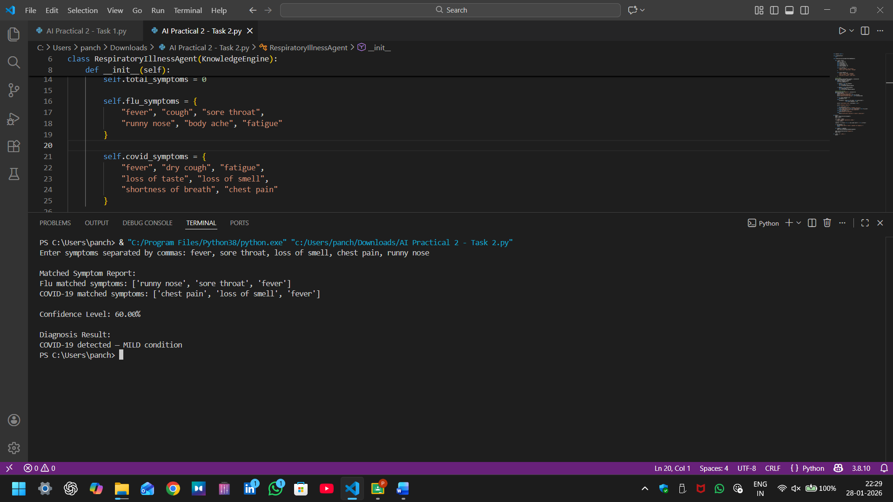

- PEAS Definition – Respiratory Illness Classification Agent

- P = Performance Measure:
- Accurate classification between Normal Flu and COVID-19
- Correct identification of COVID-19 severity (Mild or Extreme)
- Prevention of diagnosis when fewer than 3 symptoms are provided
- Correct comparison of Flu and COVID symptom counters
- E = Environment:
- User-interactive, non-clinical decision support environment.
- Static and deterministic
- Text-based input system
- A = Actuators:
- Display diagnosis result
- Prompt user to enter additional symptoms when input is insufficient
- Display advisory messages
- S = Sensors:
- User-entered symptom list
- Count of symptoms matching Flu
- Count of symptoms matching COVID-19

Thank You Sir, for your Time & Consideration.
Yours Sincerely,
Panchal Darshan
Enrolment Number: 22162121007

